# **Library Management System**

Topic: Library Management System You are going to build a project based on Library Management System. It keeps track of all information about books in the library, their cost, status and total number of books available in the library.

Create a database named library and following TABLES in the database:

1. Branch 2. Employee 3. Books 4. Customer 5. IssueStatus 6. ReturnStatus Attributes for the tables:

1. Branch Branch_no - Set as PRIMARY KEY Manager_Id Branch_address Contact_no

2. Employee Emp_Id – Set as PRIMARY KEY Emp_name Position Salary Branch_no - Set as FOREIGN KEY and it refer Branch_no in Branch table

3. Books ISBN - Set as PRIMARY KEY Book_title Category Rental_Price Status [Give yes if book available and no if book not available] Author Publisher

4. Customer Customer_Id - Set as PRIMARY KEY Customer_name Customer_address Reg_date

5. IssueStatus Issue_Id - Set as PRIMARY KEY Issued_cust – Set as FOREIGN KEY and it refer customer_id in CUSTOMER table Issued_book_name Issue_date Isbn_book – Set as FOREIGN KEY and it should refer isbn in BOOKS table

6. ReturnStatus Return_Id - Set as PRIMARY KEY Return_cust Return_book_name Return_date Isbn_book2 - Set as FOREIGN KEY and it should refer isbn in BOOKS table.

Create a database named library and following TABLES in the database:

* The Library Management System is designed to efficiently manage and maintain the details of books, employees, branches, and customers. The system includes tables for various entities, each connected through foreign keys to ensure data integrity and facilitate complex queries. This system helps librarians manage books' availability, track issued and returned books and keep records of employees and branches.
* Creating a database Library.
  + Description: This database will contain all the details of the library in the tables created.
  + Query:

CREATE DATABASE Library;

GO

USE Library;

GO

1. Branch table-> Branch_no - Set as PRIMARY KEY, Manager_Id, Branch_address, Contact_no.
   1. Description: The Branch table holds information about different branches of the library. Each branch has a unique branch number and is managed by an employee.
   2. Query:

CREATE TABLE Branch (

Branch_no INT PRIMARY KEY,

Manager_Id INT,

Branch_address VARCHAR(255),

Contact_no VARCHAR(15)

);

INSERT INTO Branch (Branch_no, Manager_Id, Branch_address, Contact_no) VALUES

(1, 101, 'Mumbai', '02212345678'),

(2, 102, 'Delhi', '01112345678'),

(3, 103, 'Kolkata', '03312345678'),

(4, 104, 'Chennai', '04412345678'),

(5, 105, 'Bangalore', '08012345678'),

(6, 106, 'Hyderabad', '04012345678'),

(7, 107, 'Ahmedabad', '07912345678'),

(8, 108, 'Pune', '02012345678'),

(9, 109, 'Jaipur', '014112345678'),

(10, 110, 'Lucknow', '052212345678');

SELECT * FROM Branch;

1. Employee table-> Emp_Id – Set as PRIMARY KEY, Emp_name, Position, Salary,

Branch_no - Set as FOREIGN KEY and it refer Branch_no in Branch table.

* 1. Description: The Employee table contains details of all employees working in the library, including their positions and the branches they are associated with.
  2. Query:

CREATE TABLE Employee (

Emp_id INT PRIMARY KEY,

Emp_name VARCHAR(100),

Position VARCHAR(100),

Salary DECIMAL(10, 2),

Branch_no INT,

FOREIGN KEY (Branch_no) REFERENCES Branch(Branch_no)

);

INSERT INTO Employee (Emp_id, Emp_name, Position, Salary, Branch_no) VALUES

(101, 'Ramesh Kumar', 'Manager', 60000, 1),

(102, 'Suresh Gupta', 'Manager', 62000, 2),

(103, 'Mahesh Jaiswal', 'Manager', 63000, 3),

(104, 'Rajesh Singh', 'Manager', 64000, 4),

(105, 'Naresh Singh', 'Manager', 65000, 5),

(106, 'Dinesh Gupta', 'Assistant Manager', 55000, 1),

(107, 'Mukesh Kumhar', 'Assistant Manager', 56000, 2),

(108, 'Lokesh Rahul', 'Assistant Manager', 57000, 3),

(109, 'Jignesh Reddy', 'Clerk', 30000, 1),

(110, 'Harish Chaudhary', 'Clerk', 31000, 2),

(111, 'Prakash Raj', 'Clerk', 32000, 3),

(112, 'Amit Trivedi', 'Clerk', 33000, 4),

(113, 'Sumit Shah', 'Clerk', 34000, 5),

(114, 'Pawan Kumar', 'BPO', 40000, 1),

(115, 'Sanjay Dutt', 'Technician', 36000, 1),

(116, 'Raju Rastogi', 'Technician', 38000, 3),

(117, 'Harsh Gujral', 'Clerk', 38000, 3)

(118, 'Ravi Shastri', 'Clerk', 32000, 3);

SELECT * from Employee;

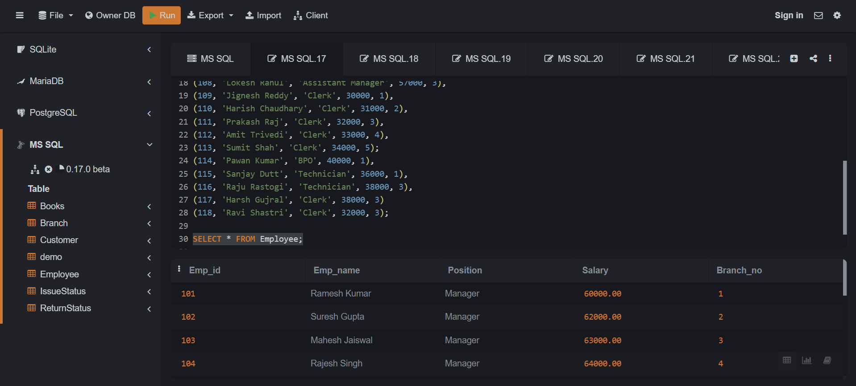

1. Books table-> ISBN - Set as PRIMARY KEY, Book_title, Category, Rental_Price, Status, [Give yes if book available and no if book not available], Author, Publisher.
   1. Description: The Books table keeps track of all books in the library, including their status (available or not), rental price, and other bibliographic details.
   2. Query:

CREATE TABLE Books (

ISBN VARCHAR(20) PRIMARY KEY,

Book_title VARCHAR(255),

Category VARCHAR(100),

Rental_Price DECIMAL(10, 2),

Status VARCHAR(3) CHECK (Status IN ('yes', 'no')),

Author VARCHAR(100),

Publisher VARCHAR(100)

);

INSERT INTO Books (ISBN, Book_title, Category, Rental_Price, Status, Author, Publisher) VALUES

('978-3-16-148410-0', 'The Great Gatsby', 'Fiction', 20.00, 'yes', 'F. Scott Fitzgerald', 'Scribner'),

('978-0-14-044926-6', 'Crime and Punishment', 'Fiction', 25.00, 'no', 'Fyodor Dostoevsky', 'Penguin Classics'),

('978-1-56619-909-4', 'War and Peace', 'History', 30.00, 'yes', 'Leo Tolstoy', 'Modern Library'),

('978-0-307-74176-3', 'The Wright Brothers', 'Biography', 22.00, 'yes', 'David McCullough', 'Simon & Schuster'),

('978-1-250-15126-0', 'A Brief History of Time', 'Science', 28.00, 'no', 'Stephen Hawking', 'Bantam Books'),

('978-0-06-231609-7', 'Sapiens', 'Non-Fiction', 27.00, 'yes', 'Yuval Noah Harari', 'Harper'),

('978-0-452-28423-4', 'The Art of War', 'History', 15.00, 'yes', 'Sun Tzu', 'Penguin Classics'),

('978-0-385-74322-4', 'The Road', 'Fiction', 20.00, 'yes', 'Cormac McCarthy', 'Vintage'),

('978-0-375-75253-0', 'The Catcher in the Rye', 'Fiction', 18.00, 'no', 'J.D. Salinger', 'Little, Brown and Company'),

('978-0-14-312779-6', 'The Boys in the Boat', 'Biography', 24.00, 'yes', 'Daniel James Brown', 'Penguin Books');

SELECT * FROM Books;

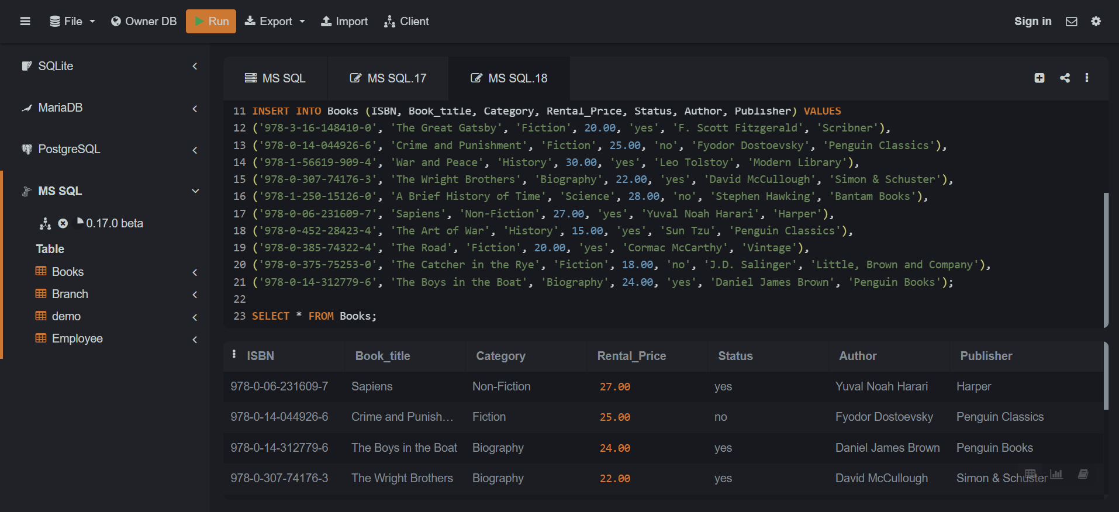

1. Customer table-> Customer_Id - Set as PRIMARY KEY, Customer_name, Customer_address, Reg_date.
   1. Description: The Customer table stores information about library customers, including their registration details and addresses.
   2. Query:

CREATE TABLE Customer (

Customer_Id INT PRIMARY KEY,

Customer_name VARCHAR(100),

Customer_address VARCHAR(255),

Reg_date DATE

);

INSERT INTO Customer (Customer_Id, Customer_name, Customer_address, Reg_date) VALUES

(301, 'Anil Sharma', 'Mumbai-Maharashtra', '2021-12-15'),

(302, 'Sunil Kumar', 'Delhi-Delhi', '2023-01-10'),

(303, 'Vinil Verma', 'Kolkata-West Bengal', '2020-05-20'),

(304, 'Rohit Gupta', 'Chennai-Tamil Nadu', '2021-11-25'),

(305, 'Manish Patel', 'Bangalore-Karnataka', '2022-08-14'),

(306, 'Rajeev Singh', 'Hyderabad-Telangana', '2023-02-10'),

(307, 'Karan Joshi', 'Ahmedabad-Gujarat', '2021-07-19'),

(308, 'Vikas Saxena', 'Pune-Maharashtra', '2020-03-30'),

(309, 'Ajay Deshmukh', 'Jaipur-Rajasthan', '2019-12-10'),

(310, 'Naveen Khanna', 'Lucknow-Uttar Pradesh', '2022-09-25');

SELECT * FROM Customer;

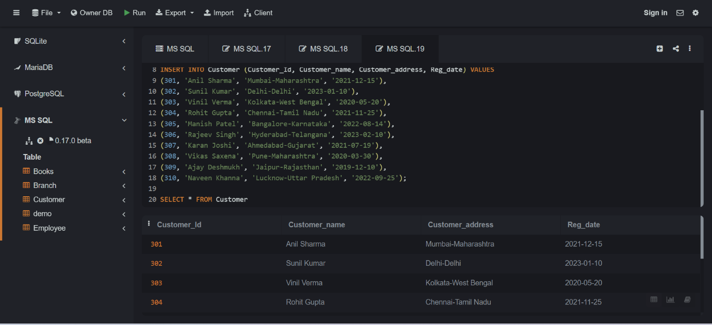

1. IssueStatus table-> Issue_Id - Set as PRIMARY KEY, Issued_cust – Set as FOREIGN KEY and it refer customer_id in CUSTOMER table, Issued_book_name, Issue_date, Isbn_book – Set as FOREIGN KEY and it should refer isbn in BOOKS table.
   1. Description: The IssueStatus table records the details of books issued to customers, linking customers and books with issue dates.
   2. Query:

CREATE TABLE IssueStatus (

Issue_Id INT PRIMARY KEY,

Issued_cust INT,

Issued_book_name VARCHAR(255),

Issue_date DATE,

Isbn_book VARCHAR(20),

FOREIGN KEY (Issued_cust) REFERENCES Customer(Customer_Id),

FOREIGN KEY (Isbn_book) REFERENCES Books(ISBN)

);

INSERT INTO IssueStatus (Issue_Id, Issued_cust, Issued_book_name, Issue_date, Isbn_book) VALUES

(401, 301, 'The Great Gatsby', '2023-06-10', '978-3-16-148410-0'),

(402, 302, 'War and Peace', '2023-06-15', '978-1-56619-909-4'),

(403, 303, 'The Wright Brothers', '2023-06-18', '978-0-307-74176-3'),

(404, 304, 'Sapiens', '2023-06-20', '978-0-06-231609-7'),

(405, 305, 'The Road', '2023-06-22', '978-0-385-74322-4'),

(406, 306, 'The Boys in the Boat', '2023-06-25', '978-0-14-312779-6');

SELECT * from IssueStatus;

1. ReturnStatus table-> Return_Id - Set as PRIMARY KEY, Return_cust, Return_book_name, Return_date, Isbn_book2 - Set as FOREIGN KEY and it should refer isbn in BOOKS.
   1. Description: customers and return dates.
   2. Query:

CREATE TABLE ReturnStatus (

Return_Id INT PRIMARY KEY,

Return_cust INT,

Return_book_name VARCHAR(255),

Return_date DATE,

Isbn_book2 VARCHAR(20),

FOREIGN KEY (Return_cust) REFERENCES Customer(Customer_Id),

FOREIGN KEY (Isbn_book2) REFERENCES Books(ISBN)

);

INSERT INTO ReturnStatus (Return_Id, Return_cust, Return_book_name, Return_date, Isbn_book2) VALUES

(501, 301, 'The Great Gatsby', '2023-07-01', '978-3-16-148410-0'),

(502, 302, 'War and Peace', '2023-07-03', '978-1-56619-909-4'),

(503, 303, 'The Wright Brothers', '2023-07-05', '978-0-307-74176-3'),

(504, 304, 'Sapiens', '2023-07-07', '978-0-06-231609-7');

SELECT * from ReturnStatus;

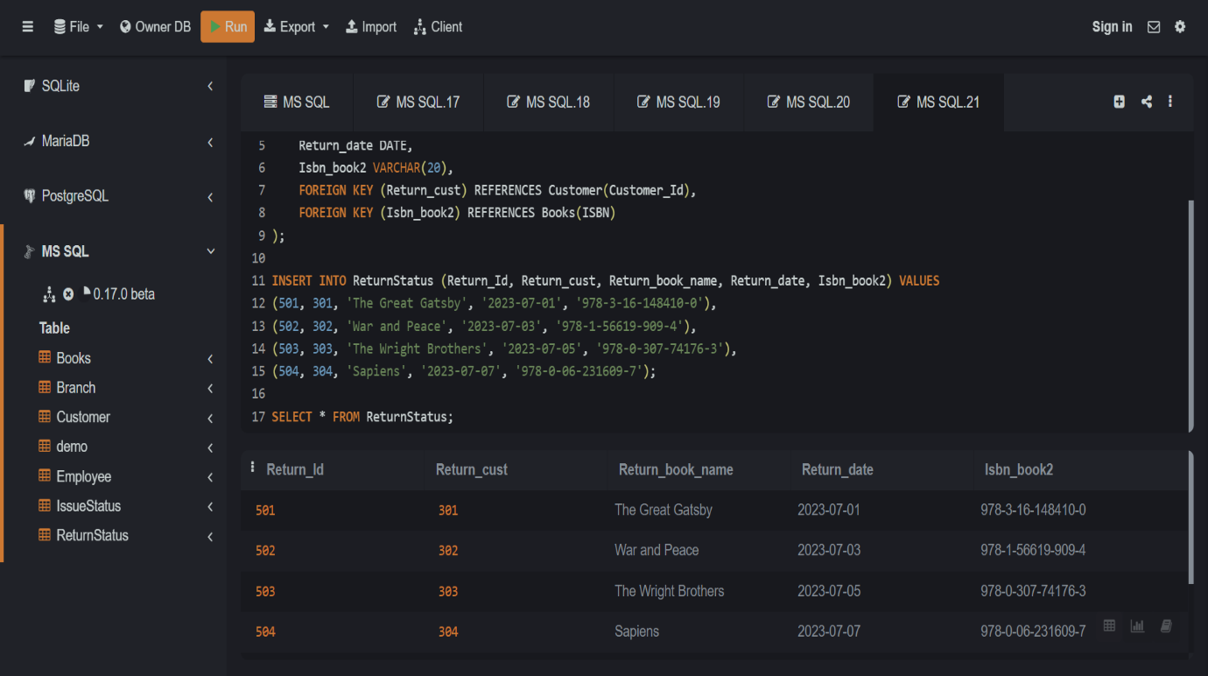

**QUERY:**

1. Retrieve the book title, category, and rental price of all available books.
   1. Description: This query fetches the title, category, and rental price of books that are currently available for borrowing.
   2. Advantages: Helps librarians quickly identify books that are available for issue, aiding in customer service and inventory management.
   3. Query:

SELECT Book_title, Category, Rental_price FROM Books

where Status='yes';

1. List the employee names and their respective salaries in descending order of salary.
   1. Description: This query lists employees and their salaries, sorted from highest to lowest salary.
   2. Advantages: Useful for management to review payroll and make informed decisions regarding salary distributions and raises.
   3. Query:

SELECT Emp_name, Salary FROM Employee

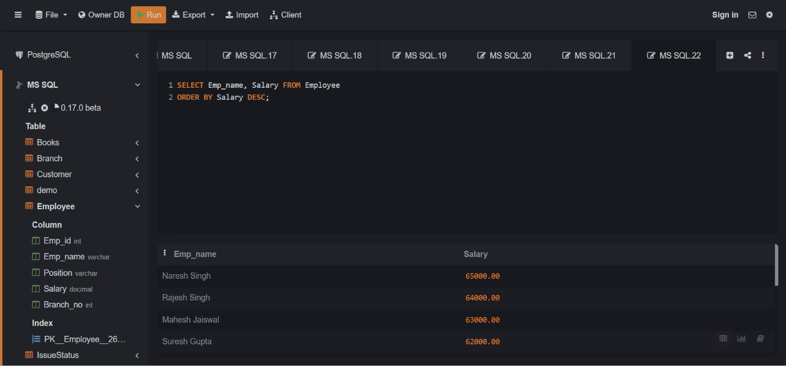ORDER by Salary DESC;

1. Retrieve the book titles and the corresponding customers who have issued those books.
   1. Description: Fetches the titles of books along with the names of customers who have issued them.
   2. Advantages: Helps in tracking which customers have which books, useful for follow-ups and overdue notifications.
   3. Query:

SELECT b.Book_title, c.Customer_name

from Books b JOIN IssueStatus i on b.ISBN=i.Isbn_book

JOIN Customer c on i.Issued_cust=c.Customer_Id;

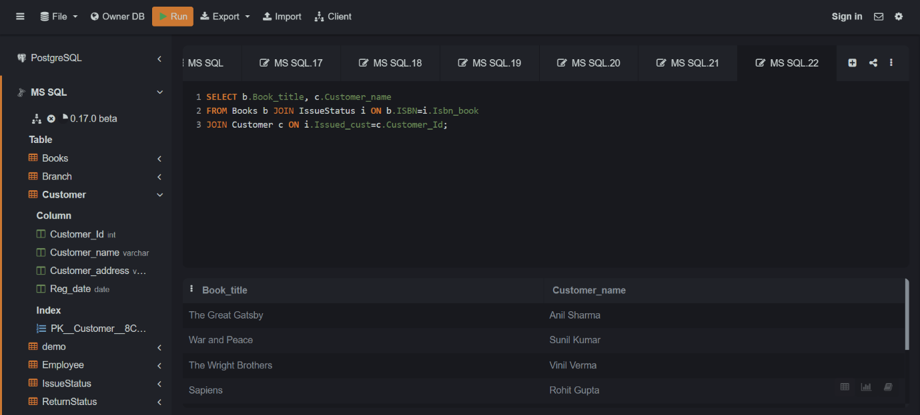

1. Display the total count of books in each category.
   1. Description: Provides a count of books grouped by their categories.
   2. Advantages: Assists in understanding the distribution of books across different genres, helping in collection development and acquisition strategies.
   3. Query:

SELECT Category, count(*) AS Total_Books FROM Books

GROUP BY Category;

1. Retrieve the employee names and their positions for the employees whose salaries are above Rs.50,000.
   1. Description: Lists the names and positions of employees earning more than Rs.50,000.
   2. Advantages: Useful for budget planning and identifying high-paid staff for potential leadership roles or salary reviews.
   3. Query:

SELECT Emp_name, Position FROM Employee

WHERE Salary>50000;

1. List the customer names who registered before 2022-01-01 and have not issued any books yet.
   1. Description: Identifies customers who registered before a specific date and have not borrowed any books.
   2. Advantages: H elps in understanding customer engagement and can be used to encourage inactive members to utilize library services.
   3. Query:

SELECT Customer_name FROM Customer

WHERE Reg_date<'2022-01-01' and Customer_id NOT IN (SELECT Issued_cust from IssueStatus);

1. Display the branch numbers and the total count of employees in each branch.
   1. Description: Provides the number of employees working in each branch.
   2. Advantages: Useful for branch managers to ensure adequate staffing and for planning resource allocation.
   3. Query:

SELECT Branch_no, COUNT(Emp_id) AS Total_Employee FROM Employee

GROUP BY Branch_no;

1. Display the names of customers who have issued books in the month of June 2023.
   1. Description: Lists customers who borrowed books during June 2023.
   2. Advantages: Helps in analyzing borrowing trends and identifying peak borrowing periods for better service management.
   3. Query:

SELECT c.Customer_name FROM Customer c JOIN IssueStatus i ON c.Customer_Id=i.Issued_cust

WHERE MONTH(i.Issue_date)=06 AND YEAR(i.Issue_date)=2023;

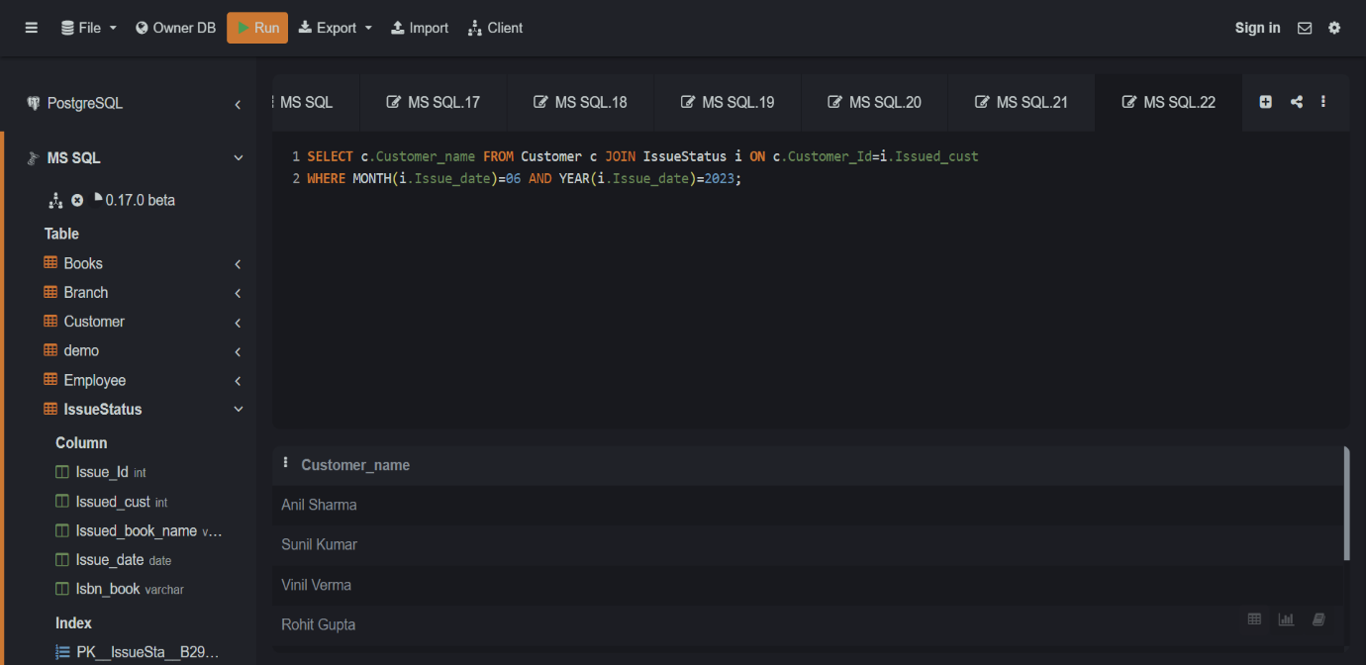

1. Retrieve book_title from book table containing history.
   1. Description: Fetches titles of books that have 'history' in their title.
   2. Advantages: Useful for users or staff searching for history-related books, aiding in quick information retrieval.
   3. Query:

SELECT Book_title FROM Books

WHERE Category='History';

1. Retrieve the branch numbers along with the count of employees for branches having more than 5 employees.
   1. Description: Lists branches with more than five employees along with the number of employees.
   2. Advantages: Helps in identifying larger branches which may need more resources or could be restructured for efficiency.
   3. Query:

SELECT Branch_no, COUNT(Emp_id) AS Total_Employee FROM Employee

GROUP BY Branch_no

HAVING COUNT(Emp_id)>5;

1. Retrieve the names of employees who manage branches and their respective branch addresses.
   1. Description: Fetches the names of employees managing branches and the addresses of those branches.
   2. Advantages: Useful for top management to quickly identify branch managers and their locations for coordination and decision-making.
   3. Query:

SELECT e.Emp_name,b.Branch_address

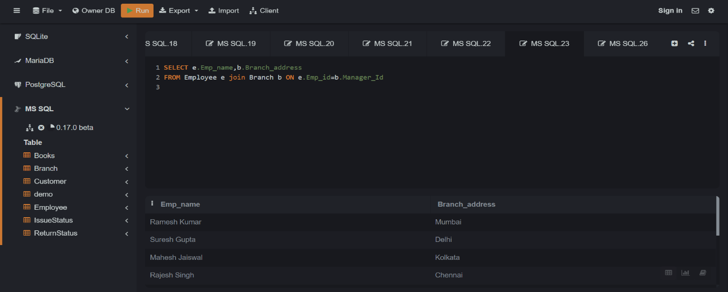FROM Employee e JOIN Branch b ON e.Emp_id=b.Manager_Id;

1. Display the names of customers who have issued books with a rental price higher than Rs. 25.
   1. Description: Lists customers who have borrowed books that cost more than Rs. 25 to rent.
   2. Advantages: Helps in identifying customers who are willing to spend more, useful for targeted marketing and service enhancements.
   3. Query:

SELECT c.Customer_name FROM Books b JOIN IssueStatus i on b.ISBN=i.Isbn_book

JOIN Customer c on i.Issued_cust=c.Customer_Id

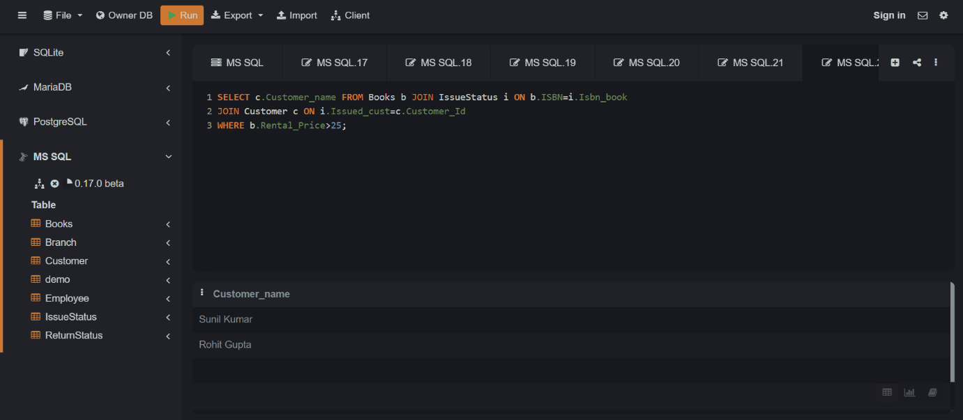WHERE b.Rental_Price>25;